 Chronic Homelessness Definition
This tool provides some sample recordkeeping tools for the Chronic Homelessness Definition. To review the exact language, please refer to 24 CFR Parts 91 & 578 and the HUD Exchange.
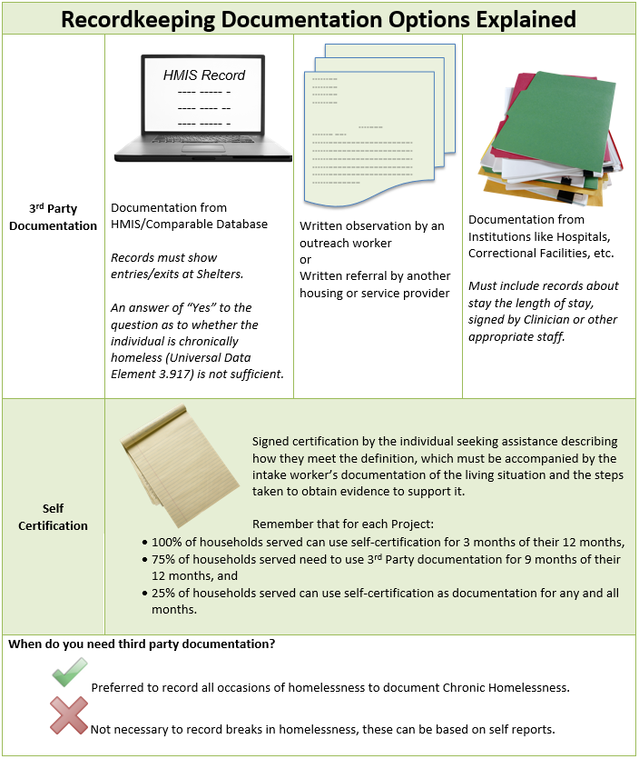

SAMPLE

Chronic Homelessness Documentation Checklist

An individual is defined by HUD as “Chronically Homeless” if they have a disability and have lived in a shelter, safe haven, or place not meant for human habitation for 12 continuous months or for 4 separate occasions in the last three years (must total 12 months). Breaks in homelessness, while the individual is residing in an institutional care facility will not count as a break in homelessness. Additionally, an individual who is currently residing in an institutional care facility for less than 90 days and meets the above criteria for chronic homelessness may also be considered chronically homeless. Lastly, a family with an adult/minor head of household who meets the above mentioned criteria may also be considered chronically homeless, despite changes in family composition (unless the chronically homeless head of household leaves the family).

Client Name: | Date of Birth:
Number in Household: | Client Head of Household: ☐ Yes ☐ No

Part 1: Current Housing Status
Client must currently be in one of these locations in order to be considered chronically homeless.
Client is currently residing:
☐ In Emergency Shelter
☐ On the Streets/Place not Meant for Human Habitation
☐ In the Safe Haven
☐ In an Institutional Care Facility (Where they have been for fewer than 90 days)

Start Date: ___________________________ | End Date: ____________________________

Location Name/Address:

Current Housing Status Notes:

Chronic Homelessness Documentation Checklist - Page 1 of 4 (Not including Attachments)

Part 2: Housing History

 | Month  # 1 | Month  # 2 | Month  # 3 | Month  # 4 | Month  # 5 | Month  # 6 | Month  # 7 | Month  # 8 | Month  # 9 | Month  # 10 | Month  # 11 | Month  # 12
Mo./Yr. | (Current Month)
Location  Check all that Apply | ☐ Streets  ☐ Shelter  ☐ Inst.  (<90 days) | ☐ Streets  ☐ Shelter  ☐ Inst.  (<90 days) | ☐ Streets  ☐ Shelter  ☐ Inst.  (<90 days) | ☐ Streets  ☐ Shelter  ☐ Inst.  (<90 days) | ☐ Streets  ☐ Shelter  ☐ Inst.  (<90 days) | ☐ Streets  ☐ Shelter  ☐ Inst.  (<90 days) | ☐ Streets  ☐ Shelter  ☐ Inst.  (<90 days) | ☐ Streets  ☐ Shelter  ☐ Inst.  (<90 days) | ☐ Streets  ☐ Shelter  ☐ Inst.  (<90 days) | ☐ Streets  ☐ Shelter  ☐ Inst.  (<90 days) | ☐ Streets  ☐ Shelter  ☐ Inst.  (<90 days) | ☐ Streets  ☐ Shelter  ☐ Inst.  (<90 days)
Doc. Type  Check One  (Except Self-Cert.  select both) | ☐ HMIS  ☐ Obsv. By Outreach  ☐ Comp. Database  ☐ Discharge Paperwork  ☐ Referral  ☐ Self-Cert.  ☐ Staff Doc. of Situation  ☐ Doc. of steps to obtain evidence | ☐ HMIS  ☐ Obsv. By Outreach  ☐ Comp. Database  ☐ Discharge Paperwork  ☐ Referral  ☐ Self-Cert.  ☐ Staff Doc. of Situation  ☐ Doc. of steps to obtain evidence | ☐ HMIS  ☐ Obsv. By Outreach  ☐ Comp. Database  ☐ Discharge Paperwork  ☐ Referral  ☐ Self-Cert.  ☐ Staff Doc. of Situation  ☐ Doc. of steps to obtain evidence | ☐ HMIS  ☐ Obsv. By Outreach  ☐ Comp. Database  ☐ Discharge Paperwork  ☐ Referral  ☐ Self-Cert.  ☐ Staff Doc. of Situation  ☐ Doc. of steps to obtain evidence | ☐ HMIS  ☐ Obsv. By Outreach  ☐ Comp. Database  ☐ Discharge Paperwork  ☐ Referral  ☐ Self-Cert.  ☐ Staff Doc. of Situation  ☐ Doc. of steps to obtain evidence | ☐ HMIS  ☐ Obsv. By Outreach  ☐ Comp. Database  ☐ Discharge Paperwork  ☐ Referral  ☐ Self-Cert.  ☐ Staff Doc. of Situation  ☐ Doc. of steps to obtain evidence | ☐ HMIS  ☐ Obsv. By Outreach  ☐ Comp. Database  ☐ Discharge Paperwork  ☐ Referral  ☐ Self-Cert.  ☐ Staff Doc. of Situation  ☐ Doc. of steps to obtain evidence | ☐ HMIS  ☐ Obsv. By Outreach  ☐ Comp. Database  ☐ Discharge Paperwork  ☐ Referral  ☐ Self-Cert.  ☐ Staff Doc. of Situation  ☐ Doc. of steps to obtain evidence | ☐ HMIS  ☐ Obsv. By Outreach  ☐ Comp. Database  ☐ Discharge Paperwork  ☐ Referral  ☐ Self-Cert.  ☐ Staff Doc. of Situation  ☐ Doc. of steps to obtain evidence | ☐ HMIS  ☐ Obsv. By Outreach  ☐ Comp. Database  ☐ Discharge Paperwork  ☐ Referral  ☐ Self-Cert.  ☐ Staff Doc. of Situation  ☐ Doc. of steps to obtain evidence | ☐ HMIS  ☐ Obsv. By Outreach  ☐ Comp. Database  ☐ Discharge Paperwork  ☐ Referral  ☐ Self-Cert.  ☐ Staff Doc. of Situation  ☐ Doc. of steps to obtain evidence | ☐ HMIS  ☐ Obsv. By Outreach  ☐ Comp. Database  ☐ Discharge Paperwork  ☐ Referral  ☐ Self-Cert.  ☐ Staff Doc. of Situation  ☐ Doc. of steps to obtain evidence
Doc. Att. | ☐Yes ☐No | ☐Yes ☐No | ☐Yes ☐No | ☐Yes ☐No | ☐Yes ☐No | ☐Yes ☐No | ☐Yes ☐No | ☐Yes ☐No | ☐Yes ☐No | ☐Yes ☐No | ☐Yes ☐No | ☐Yes ☐No

Break Mo./Yr. & Descr.  or N/A | Break 1:  Break 2:  Break 3:  If there are additional breaks please detail and attach.
Notes
Self-Cert. Check | Does the documentation include more than 3 Months of Self-Certifications? * ☐ Yes ☐ No  * Please be advised that if you answered YES, that for at least 75% of the households assisted by a recipient in a project during an operating year, no more than 3 months can be self-certified. Please check with you project administrator to ensure your project has not exceeded its self-certification cap.
Key | Mo. = Month, Yr. = Year, Inst. = Institution, Doc. = Documentation, Obsv. = Observation, Comp. = Comparable, Cert. = Certification, Descr. = Description
 | Chronic Homelessness Documentation Checklist - Page 2 of 4 (Not including Attachments)

Part 3: Disability Status
The term homeless individual with a disability' means an individual who is homeless, as defined in section 103, and has a disability that
- Is expected to be long-continuing or of indefinite duration;
  - Substantially impedes the individual's ability to live independently;
  - Could be improved by the provision of more suitable housing conditions; and
  - Is a physical, mental, or emotional impairment, including an impairment caused by alcohol or drug abuse, post-traumatic stress disorder, or brain injury;
- Is a developmental disability, as defined in section 102 of the Developmental Disabilities Assistance and Bill of Rights Act of 2000 (42 U.S.C. 15002); or
- Is the disease of acquired immunodeficiency syndrome or any condition arising from the etiologic agency for acquired immunodeficiency syndrome.
The head of household has been diagnosed with one or more of the following (check all that apply):
☐ Substance use disorder
☐ Serious mental illness
☐ Developmental disability
☐ Post-traumatic stress disorder
☐ Cognitive impairments resulting from brain injury
☐ Chronic physical illness or disability
☐ Other:
Documentation Attached:
☐ Written verification of the disability from a licensed professional;
☐ Written verification from the Social Security Administration;
☐ The receipt of a disability check; or
☐ Intake staff-recorded observation of disability that, no later than 45 days from the application for assistance, accompanied by supporting evidence.
Disability Notes:

Chronic Homelessness Documentation Checklist - Page 3 of 4 (Not including Attachments)

Part 4: Staff and Client Certifications

Client Certification:
To the best of my knowledge and ability, all the information provided in this document is true and complete. I also understand that any misrepresentation or false information may result in my participation being cancelled or denied, or in termination of assistance. It is my responsibility to notify _______________________ of any changes in my housing status or address in writing during program participation and I understand that my application may be cancelled if I fail to do so.

Client Name: (Printed) | Client Signature: | Date:

Staff Certification:
To the best of my knowledge and ability, all of the information and documentation used in making this eligibility determination is true and complete.

Staff Name: (Printed) | Staff Signature: | Date:
Staff Role: | Agency:

Notes:

Chronic Homelessness Documentation Checklist - Page 4 of 4 (Not including Attachments)

